Own Village Advancement (OVA)

Airport Road,Lalmonirhat

*Project related Some Picture*

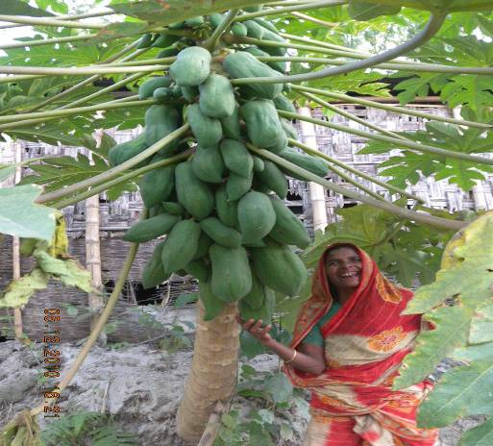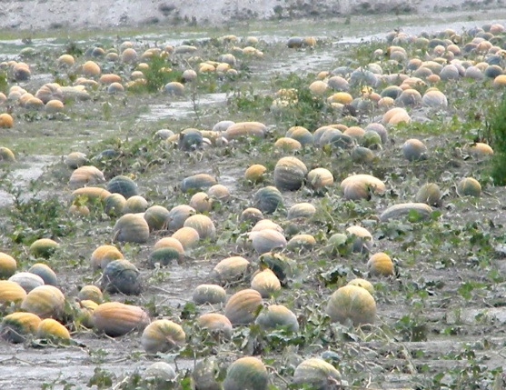

A happy woman with her homestead Product

Sandbar harvesting Stage of a Pumpkin field

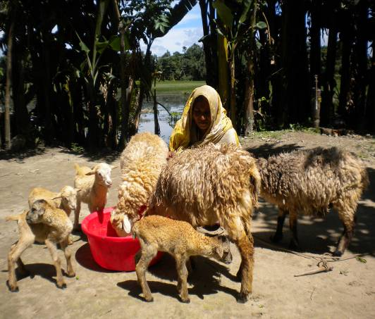

**A sheep owner is engaged in rearing of her sheep**

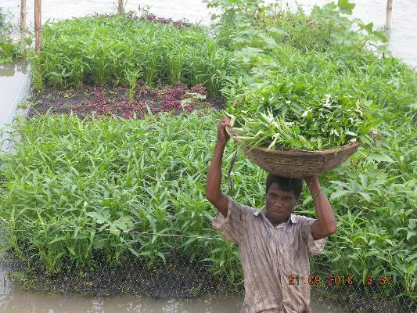

A happy floating garden owner with her Product

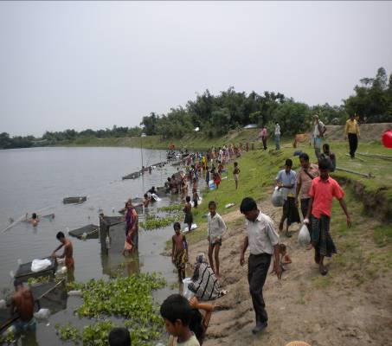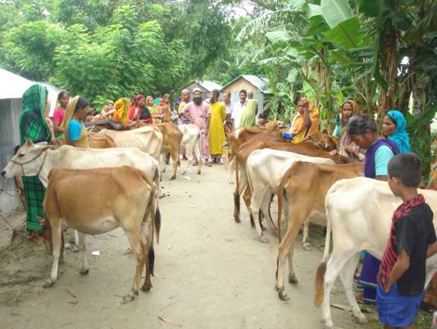

**Fingerlings distribution after the Cage aquaculture training**

Heifer distribution among the trained BHHs

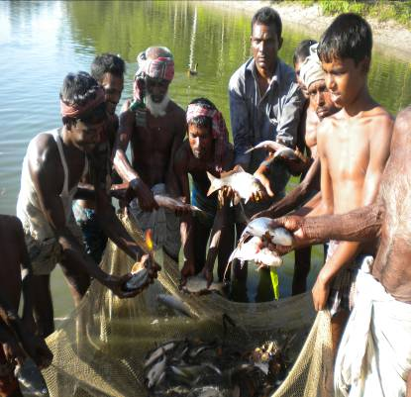

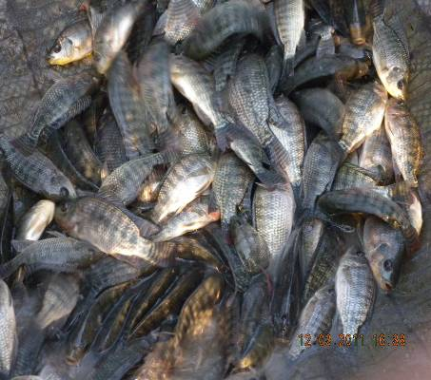

**Harvested fish from the cage**

**Harvested fish from the CBFM**

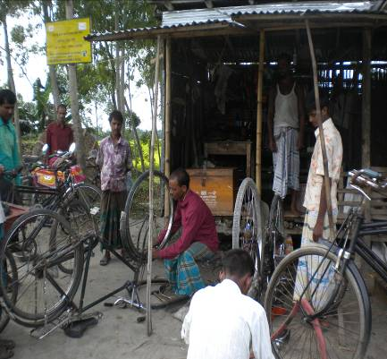

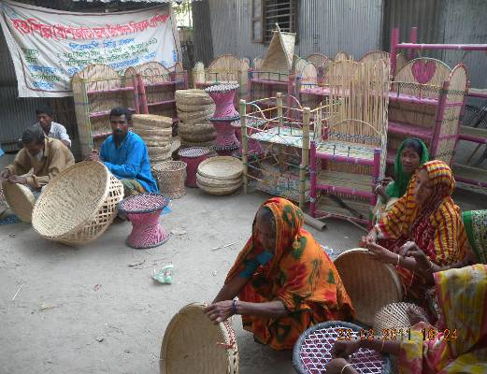

**Hamid is busy at his workshop**

**Bamboo made product in training program**

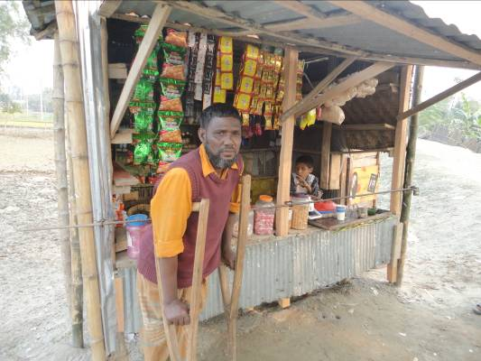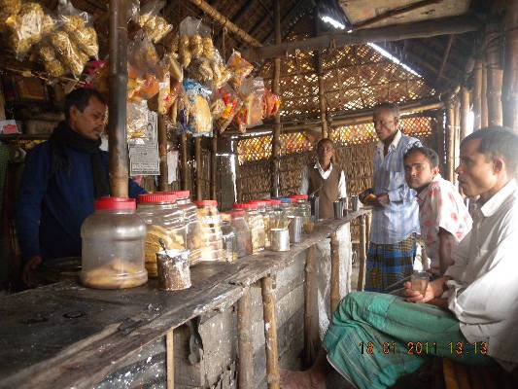

**An agro-processor is selling his product in his shop**

**A PWDs person with his project supported shop**

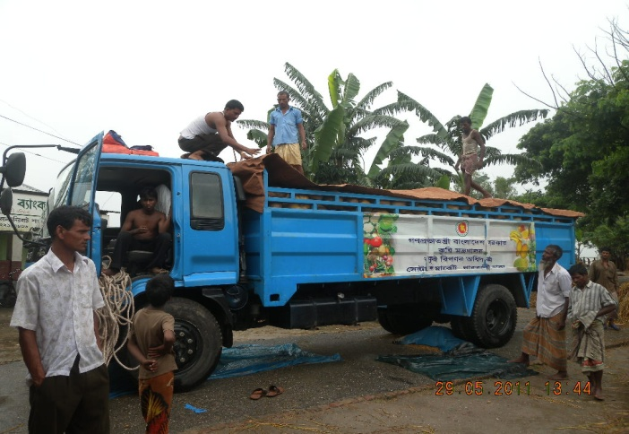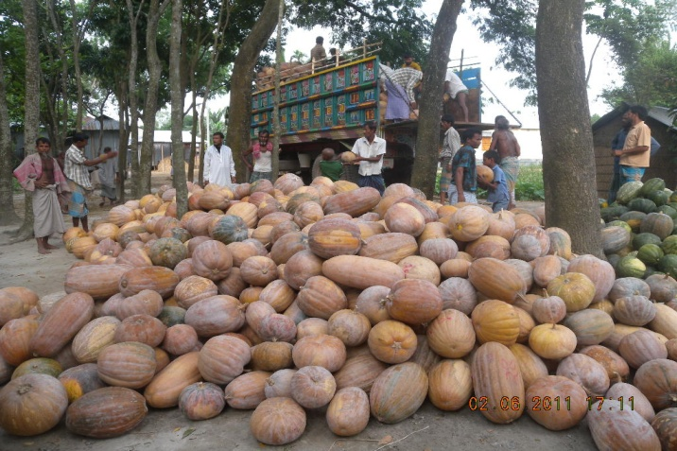

Pumpkin marketing at local level through Sandbar Cropping